**The Enhanced Greenhouse Effect**

Multiple Choice

1. State a common type of fuel before the Industrial Revolution.
2. Uranium
3. Charcoal
4. Batteries
5. Coal
6. State the preferred fuel during the Industrial Revolution.
7. Water
8. Uranium
9. Coal
10. Charcoal
11. Recall why burning coal is worse than burning charcoal.
12. The carbon in coal is in a much slower part of the cycle.
13. The carbon in coal is outside of the carbon cycle.
14. The carbon in charcoal is made from trees.
15. The carbon in charcoal is naturally occuring.
16. Explain how increased coal use marked the beginning of the enhanced greenhouse effect.
17. Making charcoal was a carbon sink.
18. Burning coal releases stored carbon dioxide.
19. Coal burns much hotter than charcoal.
20. People started making more greenhouses.
21. What name refers to the intensification of the greenhouse effect due to human activity?
22. The greenhouse effect
23. The incredible greenhouse effect
24. The enhanced greenhouse effect
25. The improved greenhouse effect
26. Recall why carbon is accumulating in the atmosphere.
27. Humans have introduced more carbon sources than carbon sinks.
28. Humans have introduced more carbon sinks than carbon sources.
29. Humans have found carbon sources outside the carbon cycle.
30. The atmosphere is absorbing carbon from space.
31. List two ways we can reduce the enhanced greenhouse effect.

Select two options

Select ALL correct options

1. Reducing carbon emissions
2. Increasing carbon sinks
3. Not making more greenhouses
4. Burning wood instead of charcoal
5. Recall what someone means when they say "humans are causing the greenhouse effect".
6. "Humans are causing the enhanced greenhouse effect"
7. "Humans are causing the glasshouse effect"
8. "Animals are causing the greenhouse effect"
9. "Humans are not causing the greenhouse effect"
10. Recall how long carbon dioxide can remain in the atmosphere.
11. 1 year
12. 10 years
13. 100 years
14. 1000 years
15. State which of the following is the main man-made source of carbon dioxide.
16. Making solar panels
17. Using fertilisers
18. Breathing too deeply
19. Burning fossil fuels
20. Recall the main man-made source of atmospheric methane.
21. Fossil fuels
22. Volcanoes
23. Livestock
24. Fertilisers
25. Recall how long methane can remain in the atmosphere.
26. 1 year
27. 10 years
28. 100 years
29. 1000 years
30. Recall the second biggest man-made source of methane.
31. Coal mines
32. Politicians
33. Corn fields
34. Rice paddles
35. Recall the main man-made source of nitrous oxide.
36. Using fertilisers
37. Drag racing
38. Dentistry
39. Burning fossil fuels
40. State how long nitrous oxide can remain in the atmosphere.
41. 1 year
42. 10 years
43. 100 years
44. 1000 years
45. List TWO things that CFCs were originally used for.

Select ALL correct options

1. Automobiles
2. Refrigerators
3. Fertilisers
4. Aerosol sprays
5. Recall how long CFCs can remain in the atmosphere.
6. Days
7. Months
8. Years
9. Hundreds of years
10. Identify which greenhouse gas is produced when we burn fossil fuels.
11. Methane
12. CFCs
13. Carbon dioxide
14. Nitrous oxide
15. Identify which greenhouse gas is produced by livestock and rice paddies.
16. Methane
17. Carbon dioxide
18. Nitrous Oxide
19. CFCs
20. Identify which greenhouse gas sees increased production due to fertiliser usage.
21. Nitrous oxide
22. CFCs
23. Carbon dioxide
24. Methane
25. Identify which greenhouse gas is no longer used due to the damage it does to the ozone layer.
26. Carbon dioxide
27. CFCs
28. Nitrous oxide
29. Methane

The following questions uses the below graph.

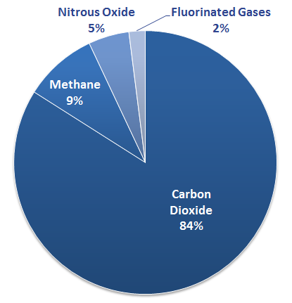

1. This graph shows human greenhouse gas emissions.

State how many different greenhouse gases humans produce.

1. 1
2. 2
3. 3
4. 4
5. This graph shows human greenhouse gas emissions.

Select the option that is not shown on this graph.

1. Methane
2. Fluorinated gases
3. Carbon dioxide
4. Nitrogen dioxide

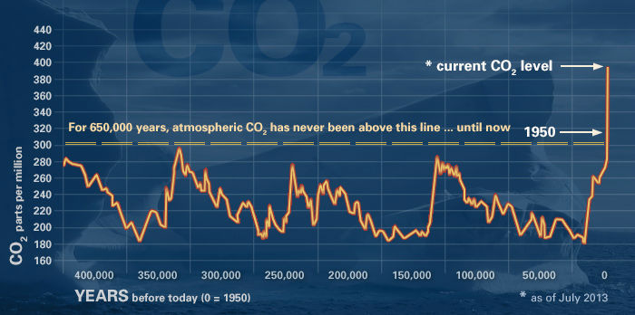

This graph shows atmospheric carbon dioxide levels over the last 400,000 years.

Use this graph to select which of the following statements are true.

1. CO2 levels cannot be measured.
2. CO2 levels are currently part of a regular cycle.
3. CO2 levels are higher than they have been in over 400,000 years.
4. CO2 levels are due to drop within the next few years.